# Detecting Highrisk Taxpayers Using Data Mining Techniques

## A PROJECT REPORT

***Submitted by***

**PRATYUSH KUMAR [Reg No: RA1711003030019]**

**ANURAG SINGH BHADORIA [Reg No:RA1711003030046]**

*Under the guidance of*

**Mr. PRAMOD NAGAR**

(Assistant Professor, Department of Computer Science & Engineering)

***in partial fulfillment for the award of the degree of***

BACHELOR OF TECHNOLOGY

in

**COMPUTER SCIENCE ENGINEERING**

Of

FACULTY OF ENGINEERING AND TECHNOLOGY



Delhi NCR Campus, Modinagar, Ghaziabad (U.P)

MAY 2021

**SRM INSTITUTE OF SCIENCE & TECHNOLOGY**

(Under Section 3 of UGC Act, 1956)

**BONAFIDE CERTIFICATE**

# Certified that this project report titled “Detecting Highrisk Taxpayers Using Data Mining Techniques” is the bonafide work of “**PRATYUSH KUMAR[Reg No: RA1711003030019]**”and “**ANURAG SINGH BHADORIA[Reg No: RA1711003030046]”** who carried out the project work under my supervision. Certified further, that to the best of my knowledge the work reported herein does not form any other project re- port or dissertation on the basis of which a degree or award was conferred on an earlier occasion on this or any other candidate.

### SIGNATURE SIGNATURE

### 

Mr Pramod Nagar Dr. R. P. MAHAPATRA

### **GUIDE HEAD OF THE DEPARTMENT**

Assistant Professor Dept. of Computer Science Engineering

Dept. of Computer Science & Engineering

Signature of the Internal Examiner Signature of the External Examiner

**ABSTRACT**

Taxpayer means as the name refers to a person or organization who wants to pay a specific amount or tax to the government on its income. Risk refers to loss of anything, but look at from the angle of government tax its a avoid of paying tax on time. Sometimes, On purpose people show their income low to avoid the government tax. Hiding information of buying ,selling of properties in the form of lands it's also one type of risk in government tax. Because of these risks, the government suffers from a lot of difficulties during the audit period. Government faces the challenge of identifying and collecting taxes that have successfully hidden from paying the proper tax; it's also called as Tax fraud. Sometimes, Taxpayers misrepresent the financial facts to the government, is also tax fraud.

The main purpose of this system is to design and find out the high risk taxpayers and notify the amount of tax to the high risk taxpayers so that it would never forget to pay the government tax. In this system, various methods are used like Classification, Association, Regression, Data mining to detect the high risk taxpayers. This system classifies the risk according to how much tax the person wants to pay. This tax is associated with the person based on their income. High risk taxpayers means the person who wants to pay a high amount of tax. If these taxpayers are increasing day by day, the government wants to suffer economic problems in our country and how the government works for our country. Therefore, this system is helpful not only to detect the high risk taxpayers but also to resolve this drawback.

**Keywords:** Taxpayer, Risk, Tax fraud detection, Classification, Association, Regression, Data mining, High risk taxpayers.

**ACKNOWLEDGEMENT**

We would like to express our gratitude to our guide, Mr. Pramod Nagar for his valuable guidance, consistent encouragement, personal caring, timely help and providing us with an excellent atmosphere for doing the research. All through the work, in spite of his busy schedule, he has extended cheerful and cordial support to us for completing this research work.

**Pratyush**

**Anurag**

INDEX

|  |  |  |
| --- | --- | --- |
| SR.NO | TITLE | PG.NO |
| 1) | INTRODUCTION | 1 |
| 2) | LITERATURE SURVEY | 5 |
| 3) | PROBLEM DEFINITION | 8 |
| 4) | REQUIREMENT ANALYSIS | 11 |
| 5) | PLANNING AND ESTIMATION | 13 |
| 6) | ALGORITHM | 15 |
| 7) | IMPLEMENTATION | 22 |
| 8) | ADVANTAGES & DISADVANTAGES | 27 |
| 9) | FUTURE MODIFICATIONS | 29 |
| 10) | APPLICATION | 31 |
| 11) | BIBLIOGRAPHY | 33 |
| 12) | SCREENSHOTS | 48 |
| 13) | SOURCE CODE |  |

**Chapter 1**

**INTRODUCTION**

**INTRODUCTION**

Tax fraud is a major issue that incurs expenses in terms of the loss of government revenues, those results in less economical tax programs and therefore the inequity between fraud taxpayers and honest taxpayers. Tax administration is under increasing pressure, since the monetary crisis of 2008 and therefore the massive deficits that followed, to collect extra tax revenues and cut back commercial enterprise fraud. Effective management of tax fraud requires addressing a basic applied mathematics drawback of non-detection, which may bias estimates of the quantity of fraud and therefore the relative fraud propensities of various social economic teams. Tax fraud detection involves processing an oversized quantity of information in search of fraud behavior that needs quick and economical algorithms, among that data processing provides relevant techniques that may facilitate tax administration to take preventive measures and improve tax style. Monetary misrepresentation discovery apparatuses are conveyed to grand to manage this downside and to create solid answers for business. Extortion is for the most part found through anomaly recognition strategy empowered by information handling methods, that additionally decide significant data by uncovering covered up patterns, connections, designs found in a really huge data set. Data processing, defined as “a method that uses statistical, mathematical, artificial intelligence, and machine learning techniques to extract and determine helpful information and subsequently gain information from an outsized database”, could be a major contributor for detecting differing types of financial fraud through its numerous ways, such as, logistic regression, decision tree, support vector machine (SVM), neural network (NN) and naïve bayes. a number of these techniques exceed the others in specific financial contexts. Despite the rise within the use of those screening and classification models for police work fraud patterns homeward-bound at audit designing, there are not any studies that focus on the identification of tax advantages within the taxation structure that area unit a lot of doubtless to be utilized by potential fraud taxpayers. To boot, this proposal to phase and characterize potential dishonorable taxpayers also can be applied to differing kinds of taxes. Data mining techniques are used in this system like regression, classification, clustering.

**Aim of Project**

To find money fraud victimization processing tools at intervals one decade and communicate this trends to educational students and industry practitioners

**Objectives of the Project :**

The targets of the identification high danger citizens abuse handling procedures are :

1. To utilize a data mining strategy to fortify government avoidance discovery execution.
2. Utilizing a preparing method a screening structure is created to channel achievable rebellious tank reports which might be dependent upon any examining T
3. o investigate anyway charge organizations may make utilization of information mining to reinforce charge consistency among the citizens
4. To empower improvement in charge organization
5. To try not to distort the money truth or assessment to the govt
6. To have a framework that upholds the expense organization of cases and errands

**Scope of the Project**

Tax avoidance is normally performed by the citizens to diminish liabilities and this illicit activity is typically performed to distort the money realities to the govt this framework is utilized to get high danger citizens who try not to cover individual assessment this framework utilizes preparing methods the preeminent point of this examination is to investigate handling procedures for misrepresentation charge forecast in preparing strategies issues like assessment misrepresentation recognition are at times outlined as arrangement issues foreseeing an unmistakable class mark yield given a data perception the principal handling methods utilized for charge misrepresentation recognition are supply models counterfeit neural organizations the bayesian organization and decision trees.

**Chapter 2**

**LITERATURE SURVEY**

|  |  |  |  |  |
| --- | --- | --- | --- | --- |
| **Title** | **Authors** | **Advantages** | **Disadvantages** | **Result** |
| **Detection of High risk taxpayer** | John Wang | This method is used to detect high risk taxpayers in a minimum amount of time. | System output accuracy is quite less to detect the taxpayers. | Data mining technique used in this system. |
| **Data mining** | James G.S. Yang | The power of this system is the combined use of regression techniques, support vector machines and prioritizing the high-income taxpayers. | Time to predict the output is not precised. | Based on Data mining ,We come to know high risk taxpayers. |
| **Tax calculation** | R.K. Tewari | The main feature is the amount of taxable income based on which the purchasing, sales, revenue and profit can be calculated. | Include the misclassification costs. | This system decreases the number of high risk tax payers. |
| **Tax payers** | Yong Wang | The precision of this system is the use of support vector machines and prioritizing the high-income taxpayers. | System takes much time to compile the input fields | Discovering fraud tax payers with potential tax responsibility and Improving compliance of tax diductors |
| **Predictive Analytics For Controlling Tax Evasion** | Sandeep Kumar K | The logistic regression model we built predicts with high accuracy | Include the misclassification costs. | Lift chart is a measure of the effectiveness of a predictive model calculated as the ratio between the results obtained with and without the predictive model |
| **Using data mining technique to enhance tax evasion detection performance** | Roung-Shiunn Wu a , C.S. Ou b , Hui-ying Lin b , She-I Chang b , David C. Yen c | Personnel perform their tax evasion screening tasks more efficiently, thereby enhancing the productivity of auditing possible tax evasion cases. | Basic method used to find taxpayers | They were use 3 datasets and the accuracy based on there dataset above 95% |
| **HIGH PERFORMANCE IMPLEMENTATION OF TAX FRAUD DETECTION ALGORITHM** | Mehdi Samee Rad, Asadollah Shahbahrami | Implementation results on some real data show that a performance improvement of 9.2x is achieved using available parallel patterns in .Net framework | System is required more time to run the program | Running the program in serial mode was time consuming. So in this study we tried to rely on new parallelism technology and apply it on parts of procedure to reduce the running time of the program. |
| A Comprehensive Survey of Data Mining-based Fraud Detection Research | CLIFTON PHUA, VINCENT LEE, KATE SMITH & ROSS GAYLER | This field can benefit from other related fields. Specifically, | Detection time is too long for an event-driven system | This survey clearly defines the underlying technical problems and covers more relevant fraud types, methods, and techniques than any of the other survey papers |

**Chapter 3**

**PROBLEM**

**DEFINITION**

**Problem Statement**

Administration of our nation experiences a few monetary issues on account of this high danger citizens this citizens address some unacceptable money related realities to the govt once in a while people deliberately show their benefit low to pay the base amount of duty to the govt government needs right expense on time else they're going to not work for the country to beat this disadvantage this strategy is utilized this strategy distinguishes the high danger citizens what's more instruct them the sum regarding charge when the hard expense

**Existing System**

In our existing framework upheld the investigation of the audited articles all through this space its prepared to arrange charge misrepresentation at an undeniable level into four significant classes specifically spending extortion bank extortion and entirely unexpected associated cash extortion it shows the quantity of articles found in such a money misrepresentation though the small things of the diagram address those numbers in rates its clear that spending misrepresentation and bank extortion address the main bit this extent compares to 41 articles out of the sixty 5 explored articles the projected order structure can function as a kind of perspective in managing cash extortion location examination through giving assistance to understudies in unmistakable territories that need further consideration this system will significantly offer exchange experts partner lists to choose the appropriate preparing method for a chose setting of money related misrepresentation for instance organizations that experience the ill effects of mastercard misrepresentation they need the partner hazard of abuse any of the directed learning instruments for example grouping neural organization and svm and its encouraged to go with the principal ofttimes utilized strategy choice tree as noticed this option relies upon the misrepresentation setting and handling strategy recurrence yet it'll be else upheld execution table seven and chart one past feature the yearly conveyance of the sixty 5 articles across the 10-year amount the dark featured years 2008 2009 2010 and 2011 represent very couple of distributions in real money extortion discovery this high pace of distributions mirrors a pivotal development in real money extortion across ventures consistently in particular there had been an emotional increment of the composed papers all through 2011 this increment gave the impression to be a characteristic reaction to the flood of extortion exercises there in year a 13 increment of monetary misrepresentation in 2011 contrasted with the earlier year

**Disadvantages of Existing System:**

1. System is not précised.
2. Detecting area is limited.

**Proposed System**

The proposed characterization system can fill in as a kind of perspective in directing financial extortion recognition examination through giving the assistance to determine the troublesome regions that require huge loads of consideration this structure will significantly offer business experts a record to choose the worthy handling method for a particular setting of financial misrepresentation for example organizations that experience the ill effects of mastercard misrepresentation they need a choice of utilizing any of the regulated learning instruments ie guileless bayes choice tree neural organization and svm and its encouraged to go with the preeminent continuous utilized strategy choice tree as noticed this decision depends on the misrepresentation setting and preparing procedure recurrence

**Advantages of Proposed System:**

1. This method is used to detect high risk taxpayers in a minimum amount of time.
2. The power of this system is the combined use of regression techniques, support vector machines and prioritizing the high-income taxpayers.
3. The main feature is the amount of taxable income based on which the purchasing, sales, revenue and profit can be calculated.
4. This system Discovers fraud tax payers with potential tax responsibility and Improving compliance of tax deductors.

**Methodology**

* Machine learning classification:-

Following algorithms will be applied on features obtained above.

1. **Decision tree :-**

Decision tree fabricate characterization or relapse models inside the plan of a tree structure. It separates a dataset into more modest and more modest subsets though at steady time a related Decision tree is gradually evolved. the final word result's a Decision tree with call hubs and leaf hubs. a decision hub (e.g., Outlook) has 2 or extra branches (e.g., Sunny, Overcast and Rainy). Leaf hub (e.g., Play) addresses an arrangement or call. The highest choice hub during a Decision tree that relates to the solitary indicator referenced as root hub. Decision trees will deal with each downright and mathematical information.

1. **SVM (support vector machine) :-**

a help vector machine svm could even be a regulated ai model that utilizes order relapse and exceptions location calculations when giving partner svm model arrangements of named preparing data for each classification they are prepared to classify new content those are normal ai calculations svm is partner equation that characterizes the preeminent powerful choice limit between vectors that has a place with a given class svm is applied into each vector that write in code into any very data which implies text should be renovated into vector vectors are rundown of numbers that address a lot of directions in some house when svm chooses to draw best choice limit that isolates the house into a couple of sub territories accordingly during a couple of subspaces one home is for the vectors that have a place with the given classification and another for the vector that dont have a place thereto accordingly well see vector portrayals that write in code the most extreme amount data from text lets take one model

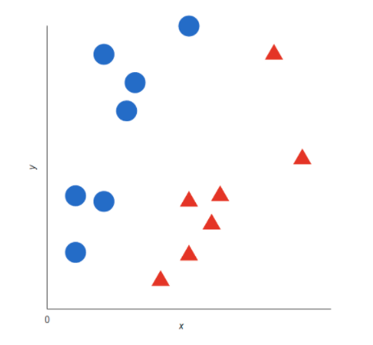

**Graph 1 :** The blue circle in the graph 1 are representation of training texts that say the pricing of product and red triangle training text. Then SVM draw best decision boundary line for this graph

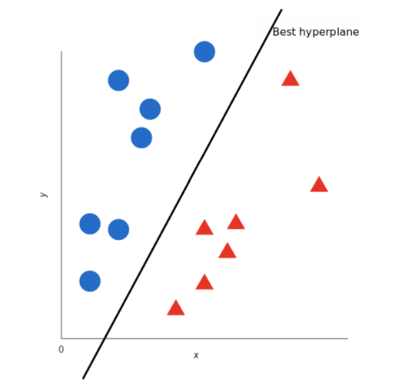

**Graph 2**

Now this is the algorithm that verifies the decision boundary for the class you wish to analyse. There are good ways of encoding text in vectors. we only have to get the representation of all the texts you'd wish to classify and check what side of the boundary those representations fall into.

1. **Multiple Logistic regression :-**

Determined backslide is that the texture genuine method to coordinate once the variable is twofold like all backslide examinations the giving backslide may similarly be a vatical assessment giving backslide is utilized to explain information and to explain the relationship between one ward matched variable and one or extra apparent ordinal length or extent level independent components

1. **Naive Bayes** :-

Naive bayes is wide utilized ai classifier and probabilistic calculation essential uses of naive bayes region unit to channel spam order archives and so on the component feed into the model is independent of each unique that is renascent the value of any of the other component utilized inside the calculation naive bayes enjoys vital benefit is that we've an adapted to confront measure prepared to coded up to foresee the yield ongoing speedy it's only climbable and old calculation is also a most reasonable alternative for planet applications that region unit needed to answer to client as by and by as feasible

Let’s take an Example:-

You have a set of reviews and classification

|  |  |  |
| --- | --- | --- |
| Sr. No. | Text | Class |
| 1 | I loved the movie | + |
| 2 | I hated the movie | - |
| 3 | A great movie. Good movie | + |
| 4 | Poor acting | - |
| 5 | Great acting. A good movie | + |

Above table define movie review with sentiment data. In on top of table there's a text column that is input and there are 10 unique words that are: - “I, loved, the, movie, hated, a, great, poor, acting, good”. categories contain the sentiment information that's negative and positive. which define that movie review is negative or positive based on 10 unique words.

Then we've got to convert above data table into features and based on that we tend to get sentiment output. 1st we have to convert it into matrix type and also have to find how many times has that word come back.

|  |  |  |  |  |  |  |  |  |  |  |  |
| --- | --- | --- | --- | --- | --- | --- | --- | --- | --- | --- | --- |
| Sr. No. | I | Loved | the | movie | hated | a | great | poor | acting | good | Class |
| 1 | 1 | 1 | 1 | 1 |  |  |  |  |  |  | + |
| 2 | 1 |  | 1 | 1 | 1 |  |  |  |  |  | - |
| 3 |  |  |  | 2 |  | 1 | 1 |  |  | 1 | + |
| 4 |  |  |  | 1 |  |  |  | 1 | 1 |  | - |
| 5 |  |  |  |  |  | 1 | 1 |  | 1 | 1 | + |

In above table unique words are comeback that is “I” word is continual in initial and second review then “Loved” word is repeated in exactly initial review and so on. in class column there are total 5 categories that's mixture of positive and negative classes in this there are 3 positive categories and a couple of negative categories. Then we've to count all the positive unique words. Then we've to calculate the likelihood against positive category therefore the probability is 3/5. Then we computing p(I) before that there's a formula that we've to refer that's

$$P(wk|+)=\frac{nk+1}{n+|vocabulary|}$$

n = no. of words in positive class

nk = number of times word occurs in class

| vocabulary | = all unique words

We add 1 in each probability thus the chance, like P(class | text) can never be zero. we are trying to determine if a data row should be classified as negative or positive. due to these we are able to ignore the divisor. therefore we have to calculate the probabilities of every classification and therefore the probabilities of every feature falling into each classification. now we have to place values in our equation

P(I | +) = = 0.0833 P(the | +) = = 0.0833 P(a | +) = = 0.125

In P(I | +) nk 1 that is I is occurred in initial document just once. This method is comparable for negative text also. however vocabulary count is constant in both the cases. Now we have to train our classifier, for that there's one formula that is

Vnb = argmax(summation of all the words occur in sentence)

That is, suppose there's a sentence like “I hated the poor acting” then 1st we've to classify all words that is therein sentence and then we have to get the likelihood to get the class that is positive or negative. thus we grab all distinctive words and then place it in above equation.

If Vj = +; p(+)P(I|+) P(I|+) P(I|+) P(I|+) P(I|+) = 6.03x10-7

If Vj = -; p(-)P(I|-) P(I|-) P(I|-) P(I|-) P(I|-) = 1.22x10-5

So get the probability of having this sentence in positive and negative. For positive classification we get 6.03x10-7 and for negative classification we get 1.22x10-5.now we have to determine whether or not sentence is classed into positive or negative. so, the answer is negative. because of 10-5. In negative values the min negative range is greater than the most negative number so that sentence get classified into negative class. Suppose there's a maximum value that is bigger than -20 then need to take log of that number and then we have to compare both the values.

**Data selection:**

The focal point of the undertaking is on the peril investigation of high danger citizens.

The dataset utilized for our task is downloaded from a US web webpage that contains genuine character identified with the risk evaluation. then we deduct every one of the invalid qualities that may not be significant assuming we utilize those invalid qualities, It can anticipate wrong answers. In this manner we've to drop those invalid qualities. At that point distinctive commotion even needs to be deterred and feed unadulterated data to the calculations. exploitation AI methodologies attempt an opportunity to get a model that foresees the client is in hazard or not assuming that client is in hazard, that approach had the chance to be applied subsequently to the client. assuming that client can't pass every one of the methodologies, which recommends he/she is in high danger citizens list.

**Finding and predicting risk:**

In our dataset hazard is absent hence we find out every one of the segments what's more, use recipes to encourage the threat section. At that point we train four AI calculations. in which we utilize gullible bayes, SVM, decision trees and arbitrary woods to foresee the correct yield. In the wake of instructing the recipe we take a look at how it will offer us a correct yield after we feed a few sources of info. so we will in general inclination exact yield with best precision.

to glance out whether that payer is in hazard or not

**Approaches:**

In monetary area and its particular space tax assessment we can't keep it to viewpoint tax collection is primary relies upon self filling affirmation kind of gain and this is regularly frequently open for extortion there are a few extortion courses in charge that is perceived by charge authorizers to handle this issue there are a few ways to deal with watch out the extortion hence we must stop this to beat we made this framework in our undertaking we utilize four methodologies that are indicative methodology change approach unpredictability approach explanation approach at the we utilize beautiful methodology at the info feature of the beautiful methodology we feed the yield of 4 approaches it'll work like if client fill all subtleties and which we confirm that client is in hazard at that point we check whether client is blessing in that four methodologies or not assuming client is blessing in a couple of approaches hazard level is high anyway client is blessing in that approaches at that point he's in high danger hence we will in general element that client into beautiful methodology practically like we check various clients regardless of whether they don't appear to be in hazard then that client can safe

**Flask:**

We use flask to create web pages for this project. For that initially we import all the dependent libraries. and initialize the app. Then we create some functions which are useful for our project and then write some functionality in that. After getting this we use one model to predict the high risk taxpayer. so when user entering into our webpage then he/she should have to fill all the details after filling all the details and submitting then that details are feed to the algorithm and predict that user is in risk or not whether user is in risk then algorithm also predict that he/she is in high risk taxpayers list and then we show our output. so it will work like an algorithm: take all details and compare with dummy data and then apply mathematical expressions to predict. In UI we import some dependent libraries which are needed. so first we import flask which is a basic library to config the all settings of flask app then we import render_template and url_for which is use to redirect on that page but before that we define some path to that page for example if i will define /index for home.html page and then on my server i will hit with /index then it will redirect to home page so redirection and routing part is done by render_template and url_for. then we import the request. It works like if we hit google.co.in on chrome then that request goes into the server database, server checks if the url is present in my database or not and then acknowledges the user.

then we import MySql to connect with our database to store user registration and login info. then we import pickle file to use pickle file at the input side

**Pickle file:**

A pickle document is somewhat of a zipper record. In that pickle document we store our data from include extraction to our model. At that point we utilize that pickle record on the input feature to foresee the yield. Real utilization of this record is for serialization and deserialization of items. convert all data into a memory unit design at that point store during this document. This pickle record is more secure and speedier. It works precisely while yielding. pickle record is direct use and expertise to recreate total python objects. When we'd prefer to foresee the yield at that point, basically pickle document activity is to arrange AI calculations and save that serialized design into a record. At that point we'll stack this record to reserialize our model and use it to make new expectations.

**Volatility approach:**

It is the level of variety of the profits for a given security, acquire or a market file throughout a measure of given time. It is the life of possibility and furthermore the change is that the standard life is used to unpredictability. though elective approach will simply be the difference between getting back from an indistinguishable security or market file. High unpredictability of safety would imply that with a little alteration inside the trouble impactful the value of money related addition or stock, the value of the security will move definitely in by the same token heading over a speedy measure of some time .

**Diagnostic methodology:**

Diagnostic methodology gives to investigate and evaluate undaunted local charge framework, analyze the strength and shortcomings of such frameworks what's more, build up a local charge mediation methodology any place required. Its higher goal is to help progressively honest and stable frameworks in low and center addition with indispensable potential for property improvement in accomplishing key income, value and intensity.

**Statement approach:**

This spending alludes to at least one among the three money related articulations that the organization uses to sum up it's financial exhibition over the reportage sum. The spending plan is also noted in light of the fact that the assertion of procuring or benefit and misfortune proclamation. This spending recipe estimation is finished by one stage or then again by different advanced techniques. inside the instance of 1 stage the spending plan is determined web acquire drops by deducting the costs from the income.

**Amendment approach:**

In the event that someone make miscount on a return they previously recorded the power licenses you to address those errors by recording a change annual government form on the off chance that the rectification brings about an expansion inside the quantity of expense you owe its for your potential benefit to document the change to keep away from likely interest and punishments on the underpayment the authority for the most part allows you to record an altered authoritative archive to address

1 your filling standing

2 the kind of wards you guarantee

3your gross increase to increment or reduction the quantity of derivation and credits you report on your unique authoritative record the authority oftentimes checks gets back to confirm numerical exactness inside the occasion it discovers a science blunder your come is consequently recalculated

**Hard voting classifier:**

Casting a ballot categorified may be an AI model that trains on partner troupe of assorted models related predicts a yield upheld their most noteworthy probability of picked class in light of the fact that the yield the best illustration of outfit model is that the arbitrary woods, that incredibly working on the calculation's rationale joins various consider tree and totals their expectations exploitation lion's share select instance of an arrangement disadvantage or by taking the avg for relapse undertakings. debilitating pick the final word class forecast is made by a dominant part vote. The figure picks the classification forecast that happens most habitually among absolute bottom models after we think about exclusively the final word yield from everything about the classifier for our pick that it's alluded to as a debilitating pick. We've utilized the debilitating pick approach by indicating pick=hard after we were starting up our democratic classifier.

**Chapter 4**

**HARDWARE & SOFTWARE REQUIREMENT**

**Hardware and Software requirements**

**Hardware:**

1. Processor: Intel Core i3 or more.
2. RAM: 4GB or more.
3. Hard disk: 250 GB or more.

**Software:**

1. Operating System : Windows 10, 7, 8.
2. Python.
3. Anaconda.
4. Spyder, Jupyter notebook, Flask.
5. MYSQL.

**Technologies Used:-**

**Python:**

Python could likewise be a taken item organized basic level language with dynamic derivation its straightforward level in-created information structures got together with unique organization and dynamic restricting sort it outrageously interesting for speedy application advancement what's more on be utilized as a pre piece or glue language to relate existing components on pythons clear direct to be told accentuation highlights quality by then decreases the cost of program fixes python maintains modules and packs that moves program quality and code utilize the python go-between and what's more the escalated standard library are offered in give or combined sort to nothing of charge for each and every fundamental stage and wish to be uninhibitedly spread oft programmers fall stricken with python because of the misrepresented strength it gives since there is no aggregation step the special stepped area test-investigate cycle is unfathomably expedient work python programs is basic a bug or unfortunate information won't ever cause a division deformity taking everything into account once the interpreter discovers a blunder it raises an extraordinary case once the program doesn't get the exception the go-between prints a stack follow a stock level program licenses assessment of local and world elements examination of self-emphatic enunciations setting breakpoints wandering through the code a line at a rapidly on the program is written in python itself vouching for pythons smart power barring generally the quick in view of right a program is to incorporate a few print clarifications to the accessibility the quick modify test-explore cycle makes this simple philosophy dreadfully amazing.

**MySQL:**

Mysql is prestigious as worlds most by and large utilized ascii archive data back-end its most guarantee data for php as php-mysql is most habitually utilized ascii record prearranging data attempt the ui that wamp lamp and xampp workers offer for mysql is ideal and diminishes our work to an outsized degree

**Chapter 5**

**PLANNING AND ESTIMATION**

**Software development Life Cycle**

The entire project spanned for duration of 6 months. In order to effectively design and develop a cost-effective model the Waterfall model was practiced.

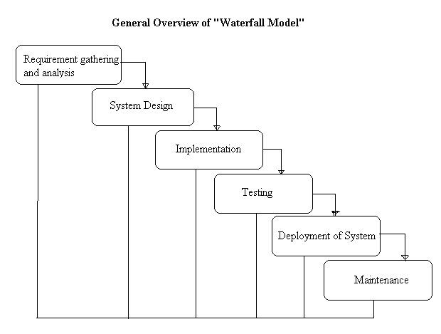

**Requirement gathering and Analysis phase:**

This phase started at the beginning of our project, we had formed groups and modularized the project. Important points of consideration were

1. Define and visualize all the objectives clearly.

2.Gather requirements and evaluate them

Consider the technical requirements needed and then collect technical specifications of various peripheral components (Hardware) required.

3. Analyze the coding languages needed for the project.

4. Define coding strategies.

5. Analyze future risks / problems.

6. Define strategies to avoid this risks else define alternate solutions to this risks.

7. Check financial feasibility.

8. Define Gantt charts and assign time span for each phase.

By studying the project extensively we developed a Gantt chart to track and schedule the project. Below is the Gantt chart of our project.

**Timeline**

**Please make changes as per your requirement**

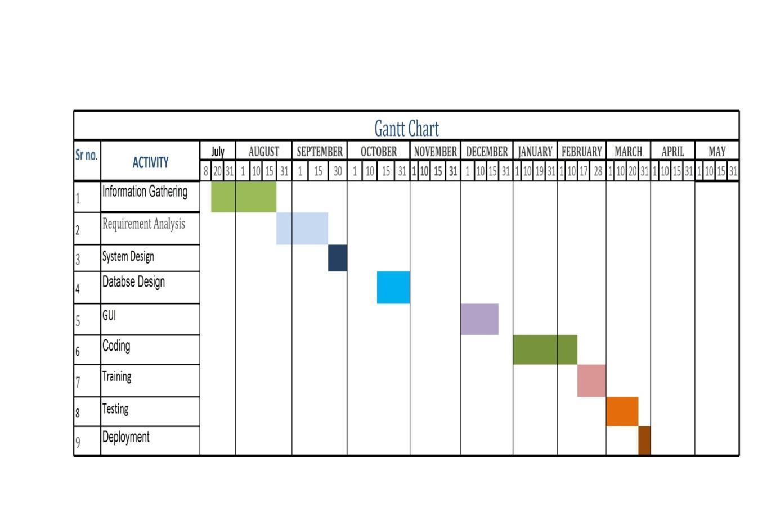

**Cost Estimation**

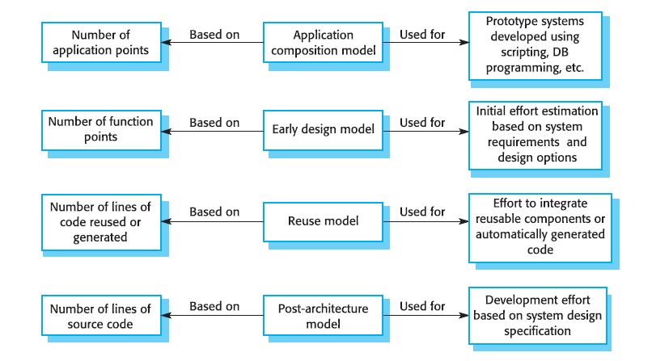

**FEASIBILITY STUDY**

This system is possible for all health care department like science lab hospital and clinic etc and this method can use while not specialists in this field anyone can use who have data concerning using online services which is able to facilitate to use this method any generation folks can use this method in laptop

**TECHNICAL FEASIBILITY**

The framework ought to be assessed from the specialized reason for read first the evaluation of this practicability ought to be upheld a rundown kind of the framework interest inside the provisions of info yield projects and techniques having known an outline framework the examination ought to keep up to suggest the kind of pack required approach building up the framework of running the framework whenever it has been planned

* Technical issues raised during the investigation are:
* Is the existing technology sufficient for the suggested one?
* Can the system expand if developed?

the undertaking should be created indicated the predetermined capacities and execution are accomplished among the limitations the task is created among most recent innovation through the innovation may become old once some measure of some time due to the specific undeniable truth that never form of same code upholds more seasoned variants the framework should in any case be utilized hence there are marginal imperatives included this task the framework has been created exploitation java the undertaking is in fact feasible for advancement

**ECONOMIC FEASIBILITY**

The creating framework ought to be even by worth and benefit. Measures to confirm that exertion is focused on a project, which may give best, come at the most punctual. one through and through the variables, that affect the occasion of a new framework, is that the value it'd need. The following are assortment of the necessary cash questions asked all through starter examination:

* The costs conduct a full system investigation.
* The cost of the hardware and software.
* The benefits in the form of reduced costs or fewer costly errors.

Since the framework is created as a neighborhood of task work, there is no manual worth to purchase the projected framework. Furthermore every one of the assets are as of now available, it offers an image of the framework is financially feasible for improvement.

**BEHAVIORAL FEASIBILITY**

This incorporates the following inquiries:

* Is there agreeable help for the clients?
* Will the arranged framework cause hurt?

The venture would be useful as an aftereffect of it fulfills the goals once created and introduced. All social perspectives are considered cautiously and presume that the undertaking is typically conceivable.

RISK ANALYSIS PROCESS

Notwithstanding the obstacle strategies utilized potential perils is in a position to which can arise inside or outside the affiliation ought to be assessed regardless of the established truth that the exact arrangement of expected catastrophes or their after results district unit delayed to outlined its valuable to play out an intensive risk investigation of all threats which can sensibly happen to the relationship in spite of the kind of peril the goals of business recuperating emerging with locale unit to validate the security of buyers workers and particular representatives eventually of and following a breakdown the overall probability of a failure happening should be settled things to appear at in urgent the probability of a particular breakdown should be constrained to represent in any case not be confined to field characteristic study of the planet closeness to indispensable wellsprings of power streams and air terminals level of receptiveness to workplaces inside the affiliation history of local service organizations in giving persistent kinds of help history of the spaces condition to standard risks neighborhood to imperative turnpikes that vehicle bold waste and combustible item. Potential openings could even be delegated regular, specialized, or human dangers. Models include:

* **Characteristic** Threats: inner flooding, outer flooding, interior hearth, outside chimney, seismic movement, high breezes, snow and ice storms, emission, cyclone, typhoon, pandemic, torrent , hurricane.
* **Specialized Threats:** power disappointment/variance, warming, ventilation or air con disappointment, glitch or disappointment of hardware , disappointment of framework code, disappointment of use code, broadcast communications disappointment, gas spills, interchanges disappointment, atomic aftermath.
* **Human Threats:** robbery, bomb dangers, theft, blackmail, thievery, defacing, psychological warfare, common problem, synthetic spill, damage, blast, war, natural pollution, radiation tainting, perilous waste, vehicle crash, airdrome nearness, strike (Internal/External), PC wrongdoing.

All areas and offices should be encased inside the peril investigation maybe than attempting to sort out real prospects of every fiasco an overall relative game plan of high medium and low is utilized at first to distinguish the probability of the danger happening the possibility investigation also need to affirm the effect of such a likely danger on various capacities or offices inside the association a risk analysis type discovered here pdf format will work with the strategy the capacities or divisions can shift by kind of association the arranging strategy ought to set up and live the possibility of every single expected danger and in this way the effect on the association if that danger happened to attempt to this each division should be investigated severally in spite of the fact that the chief framework is furthermore the one most serious danger it isn't the solitary vital concern indeed even inside the first programmed associations a few offices will not be handled or programmed inside the smallest degree in totally programmed divisions essential records stay outside the framework as lawful records pc information programming bundle hang on diskettes or supporting documentation for data section the effect is evaluated as 0 no effect or break in tasks 1 noticeable effect break in activities for as long as eight hours 2 mischief to instrumentation and additionally offices break in tasks for eight 48 hours 3 major damage to the instrumentation or potentially offices break in tasks for very 48 hours all base camp or potentially pc focus capacities ought to be resettled bound suspicions is also important to consistently apply evaluations to every possible danger

Following are run of the mill suspicions which can be utilized all through the peril evaluation measure:

1. In spite of the fact that affect evaluations may fluctuate somewhere in the range of one and three for any office given a particular situation, appraisals applied should reflect expected, apparent or anticipated effect on each space.

2. each potential danger ought to be thought to be "confined" to the force being appraised.

3. Despite the fact that one potential danger could lead on to an uncommon likely danger (e.g., a typhoon may bring forth cyclones), no aftereffect ought to be expected.

4. On the off chance that the consequences of the danger wouldn't warrant development to Associate in Nursing substitute site(s), the effect ought to be appraised no over a "2."

5. The threat evaluation should be performed by the force . to gauge the likely dangers, a weighted reason rating framework is utilized .

**Functional requirement**

In making by mental demonstrations a purposeful premium describes a perform of an item group or its section a perform is depict as a lot of information sources the lead and yields see together programming conscious prerequisites is besides calculations particular nuances data the board and cooperation and elective express rationale that format what a structure need to make a few bucks activity necessities depicting the entirety of the cases anyplace the system uses the deliberate prerequisites region unit found getting utilized cases deliberate prerequisites area unit maintained by non-utilitarian necessities similarly referenced as quality conditions that power necessities on the orchestrate or execution like execution prerequisites security or dependability by and enormous purposeful prerequisites domain unit conveyed inside the sort structure should be constrained to attempt to however non-utilitarian prerequisites district unit system are the found for discipline purposeful necessities is elucidated inside the structure style the found for discipline non-utilitarian necessities is clarified inside the system organize as represented in prerequisites arranging purposeful prerequisites show explicit delayed consequences of a system this may be separated from non-utilitarian prerequisites that affirm by and monstrous characteristics like cost and light-mindedness purposeful necessities drive the gear mastermind of a framework, though non-useful necessities drive the specialized plan of a framework.

**Non-functional requirement**

In frameworks designing and wishes designing a non-utilitarian interest may be a necessity that determines models which will be utilized to choose the activity of a framework as opposed to explicit practices this may be diverged from helpful requirements that layout explicit conduct or capacities the organize carrying out helpful requirements is intricate inside the framework style the mastermind executing non-practical requirements is intricate inside the framework plan as a rule valuable necessities diagram what a framework should embrace and do though non-utilitarian requirements layout anyway a framework should be valuable requirements square measure commonly inside such a framework will do though non-utilitarian necessities square measure framework will be non-utilitarian requirements square measure generally alluded to as characteristics of a framework elective terms for non-useful necessities square measure imperatives quality ascribes quality objectives nature of administration prerequisites and non-social prerequisites

**Chapter 6**

**TESTING**

**Testing**

Software testing methods are traditionally divided into black box testing and white box testing. These two approaches are used to describe the point of view that a test engineer takes when designing test cases.

#### ***Black box testing***

Discovery testing regards the bundle as a black box with no data of inward execution recorder testing ways include equality parceling limit value investigation all-sets testing fluff testing model-based testing detectability network beta testing and detail based testing

* **Specification-based testing**:

Assuagement based testing intends to see the common sense of programming bundle per the material necessities. In this manner, the analyzer inputs information into, and exclusively sees the yield from, the check object. This degree of checking commonly needs careful experiments to be given to the analyzer, WHO at that point will only confirm that for a given information, the yield worth (or conduct), either "is'' or "isn't" the equivalent in light of the fact that the mean per the activity . Particular based testing is basic, anyway it's light to prepare for sure dangers.

* **Advantages and disadvantages**:

The recorder analyser has no "bonds" with the code, and an analyser's discernment is incredibly basic: a code ought to have bugs. utilizing the rule, "Ask and you will get," recorder analysers notice messes with any place developers don't. Be that as it may, then again, recorder testing has been the same to be "like an enter a dull maze while not a light," as an aftereffect of the analyser doesn't keenness the pc code being tried was truly made. Accordingly, there are things once a take a look at that composes a few legitimate activities to see one thing that may be tried by only one test suite, and additionally a few components of the back-end don't appear to be tried inside the least. Hence, recorder testing enjoys the benefit of "a free assessment," from one perspective, and subsequently the impediment of "dazzle investigating," on the other.

#### *White box testing*

White box testing is previously the analyser approaches the internal data constructions and calculations likewise on the grounds that the code that carry out these.

**Sorts of white box testing:**

The accompanying kinds of white box testing exist:

* Programming interface testing (application programming interface) - Testing of the applying abuse Public and private primates
* Code inclusion - making tests to fulfil a few standards of code inclusion (either fashioner will deliver tests to make all assertions inside the program be dead at least once).
* Shortcoming infusion ways - up the inclusion of a take a look at by acquainting flaws with see code techniques
* Transformation testing ways
* Static testing - White box testing incorporates all static testing

**Code completeness evaluation**

White box takes a look acting system could likewise be acclimated esteem the fulfilment of a test suite that was made with recorder testing techniques. This permits the bundle group to appear as components of a framework that the region unit only occasionally tried and guarantees that the first fundamental work focuses are tried.

**Two basic kinds of code inclusion are:**

* Capacity inclusion, that reports on capacities dead
* Proclamation inclusion, that reports on the quantity of lines dead to end the take a look at
* They each come with a code inclusion metric, estimated as an offer.

**Chapter 7**

**Design & Implementation**

System flowchart:

A stream diagram could even be a spread of characterize that addresses a standard or strategy showing the proposes that as boxes of shifted types and their solicitation by interfacing them with bolts this depict outline shows a response for a given recoil procedure exercises territory unit depict in these compartments and bolts rather theyre calm by the sequencing of undertakings flowcharts region unit used in taking apart emerging with documenting or managing the lone way or program in a few fields

**Arrows**

Showing "stream of the board" partner bolt returning from one picture and finishing at another picture addresses that control passes to the picture the bolt focuses to. the street for the bolt is strong or broken. The significance of the bolt with broken line could differ from one stream diagram to an uncommon and ought to be laid out inside the legend.

**Generic processing steps**

Addressed as square shapes Examples: "Add one to X"; "supplant known part"; "save changes" or comparable.

**Subroutines**

Tended to as square shapes with twofold influenced vertical edges these are adjusted show tangled connection steps which may be included during an exceptionally particular language model live records one bundle may require various clear area centres or leave streams see co day by day follow forward therefore these are showed up as checked wells inside the quadrangle and subsequently the leaders bolt interface with these wells

**Input/output**

Tended to as a quadrilateral Examples: Get X from the customer; show X Prepare prohibitive drawn as a two-dimensional figure Shows exercises that don't have any outcome close to fitting a cost for a later unforeseen or elective development (see under).

**Conditional or decision**

Tended to as a gem rhombus showing wherever a decision is fundamental typically a certifiable request or genuine bogus check the prohibitive picture is whimsical during this its two bolts start of it to a great extent from total base explanation and right explanation one adore affirmed or valid and one love no or bogus the bolts had the opportunity to be named more than two bolts may moreover be utilized in any case this is regularly frequently regularly frequently generally a simple marker that a tangled choice is being taken inside that case its having the possibility to should be isolated any or replaced with the pre-portrayed live picture

**Junction symbol**

For the most part portrayed with a dark mass showing any place different administration streams meet during one leave stream an intersection picture can have very one bolt returning into it anyway only one going out in direct cases one may simply have partner bolt reason to an exceptional bolt all things being equal these are supportive to address partner monotonous strategy what in designing is named a circle a circle may for instance incorporate a connective any place the board first enters measure steps a contingent with one bolt leaving the circle and one returning to the connective for added clearness where 2 lines incidentally cross inside the drawing one through and through them could even be drawn with minimal plane figure over the other showing that no intersection is assumed

**Labelled connectors**

Addressed by A distinctive mark inside a circle. marked connectors are used in cutting edge or multi-sheet charts to fill in for bolts. for each name, the "surge" connective ought to be unmistakable, anyway there's additionally such a "inflow" connectors. During this case, an intersection up to the hustle stream is known.

**Concurrency symbol**

Addressed by a twofold cross-over line with any scope of section and leave bolts These images are utilized at whatever point 2 or extra administration streams ought to work at a comparable time. The leave streams are enacted at an identical time once the entirety of the passage streams have arrived at the simultaneousness picture. A simultaneous picture with one section stream could likewise be a fork; one with one live stream could likewise be a piece of . it is fundamental to make sure to stay these associations consistent so as. All cycles need to move from prime to base and left to right.

**Flow chart**

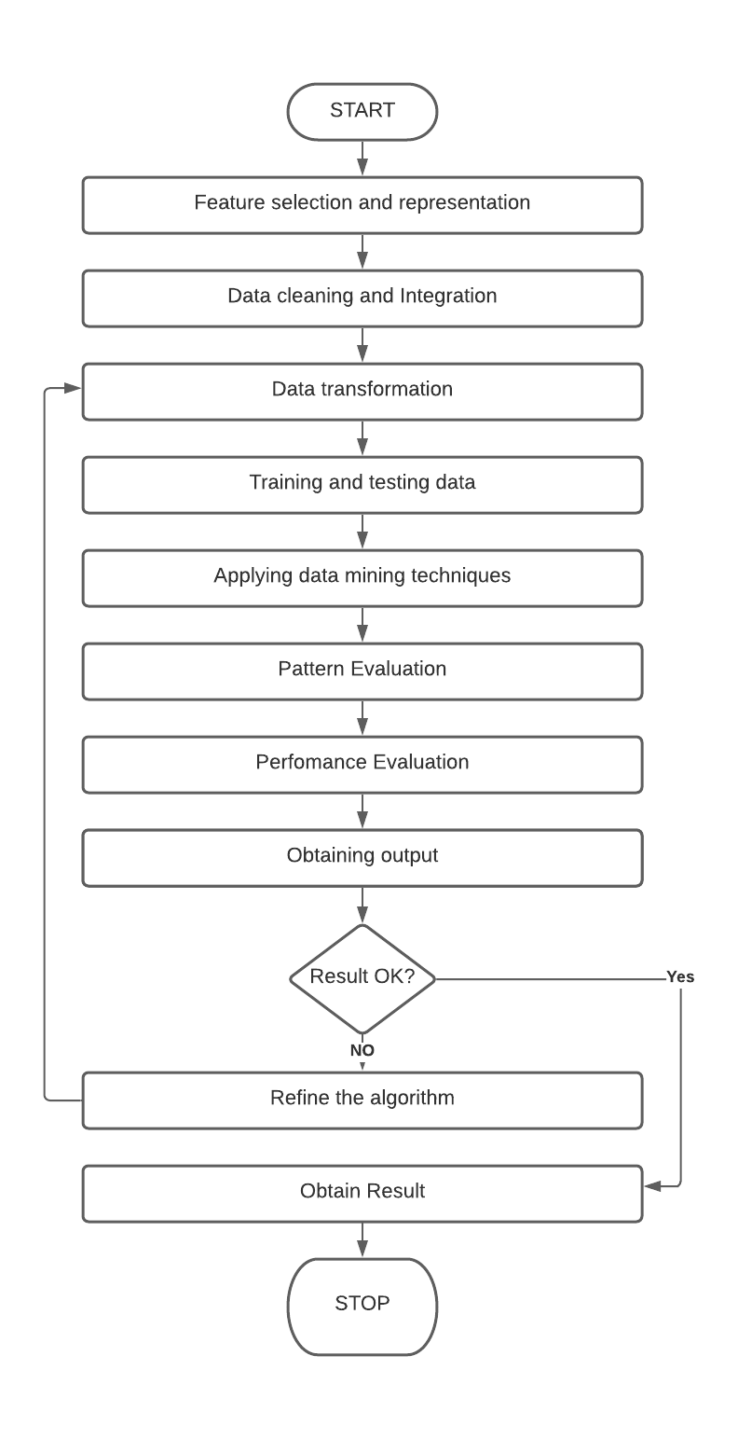

**SYSTEM IMPLEMENTATION**

Execution incorporates each one of those exercises that end up changing over from the new framework to the new. The new framework comprises of manual tasks, that is worked terribly very surprising way from the arranged new framework. a precise execution is essential to supply a dependable framework to fulfil the prerequisites of the associations. partner inappropriate establishment could affect the achievement of the prepared framework.

**IMPLEMENTATION METHODS:**

There are a few different ways for taking care of the execution and furthermore the subsequent transformation from the past to the new prepared framework.

The chief secure method for transformation from the past framework to the new framework is to run the past and new framework in equal. During this methodology, a private may work inside the manual more seasoned cycle framework still as start employable the new prepared framework. This framework offers high security, as a consequence of in spite of the fact that there is a defect inside the handled framework, we'll rely upon the manual framework. Nonetheless, the value for keeping 2 frameworks in equal is unfathomably high. This exceeds its benefits.

Another unexpected procedure may be a prompt cut over from this manual framework to the prepared framework. The correction is moreover at stretches each week or at spans on an everyday basis. There aren't any equal exercises. Notwithstanding, there is no cure only in the event of a drag. This procedure needs cautious emerging with.

A working rendition of the framework can even be upheld in one neighbourhood of the association and furthermore the faculty are having the opportunity to steer the framework and changes are made as and once required. anyway, this framework might be a more modest sum liked because of the deficiency of the entireness of the framework.

**IMPLEMENTATION PLAN:**

The execution orchestrate incorporates an outline of the relative multitude of exercises that must happen to carry out the new framework and to place it into activity. It recognizes the staff answerable for the exercises and readies a period outline for executing the framework. The execution orchestrates the subsequent stages.

* Rundown all records required for execution.
* Recognize all data expected to make new documents all through the execution.
* Rundown every single new report and strategies that enter the new framework.

The execution orchestrate ought to expect achievable issues and will be prepared to manage them. the quality issues could even be missing records; blended data designs among current and documents, blunders in data interpretation, missing data and so forth

**DFD (Data Flow Diagram)**

An information programming language dfd may be a graphical outline of the progression of information through associate in nursing framework an information programming language can likewise be utilized for the visual picture of information measure organized plan its ordinary apply for an architect to draw a setting level dfd first that shows the collaboration between the framework and out of entryways substances this setting level dfd is then detonated to implies extra detail of the framework being sculpturesque

**Architecture Diagram:**

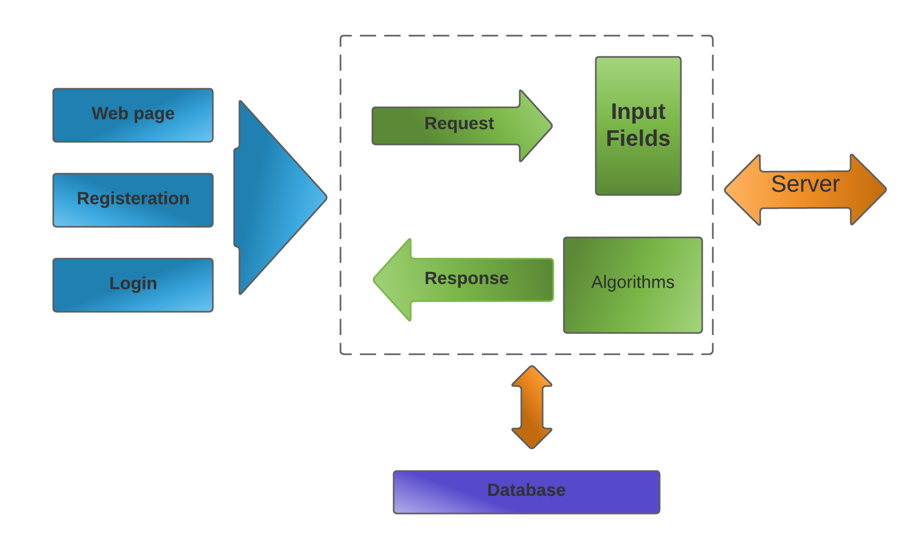

**DFD level 1**

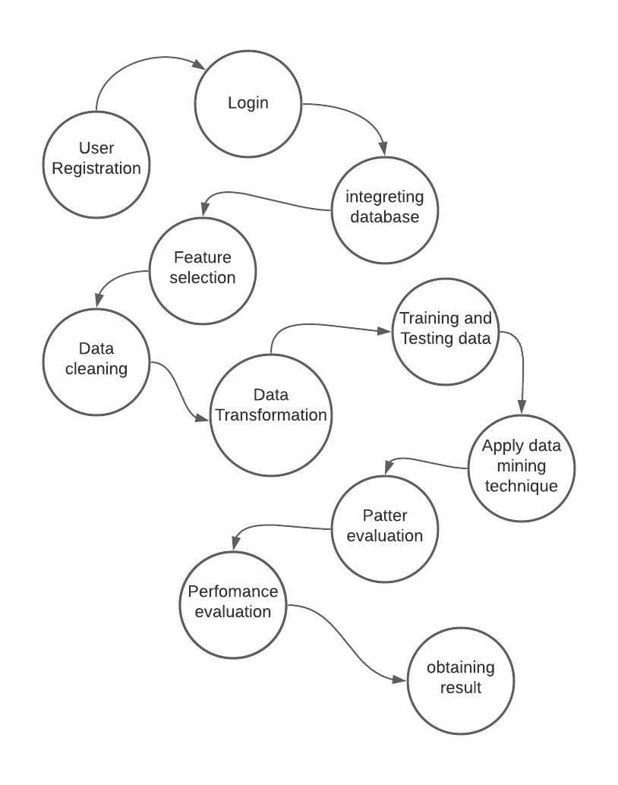

**DFD level 2:**

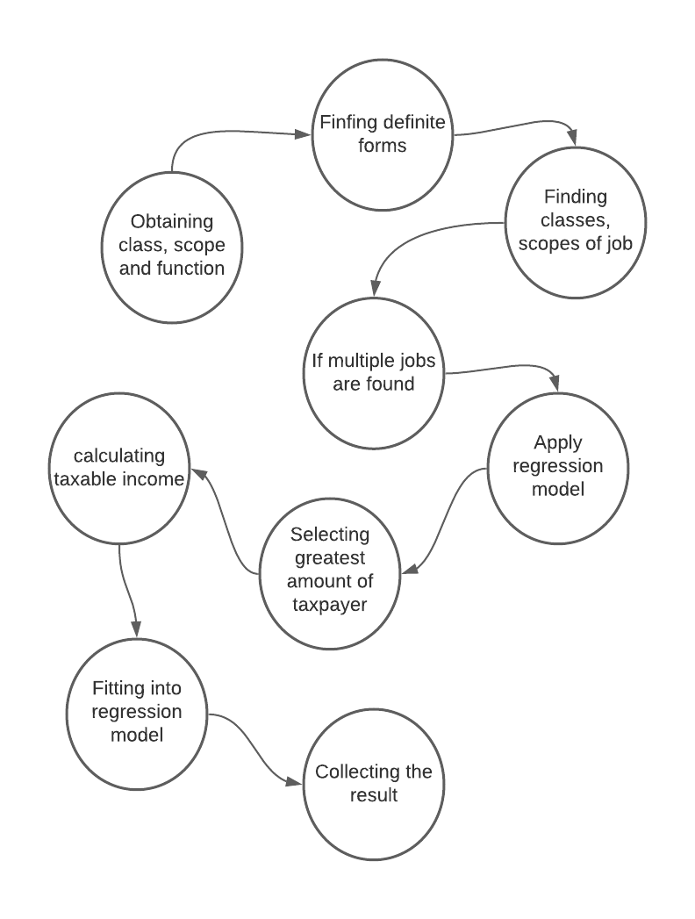

**Class Diagram:**

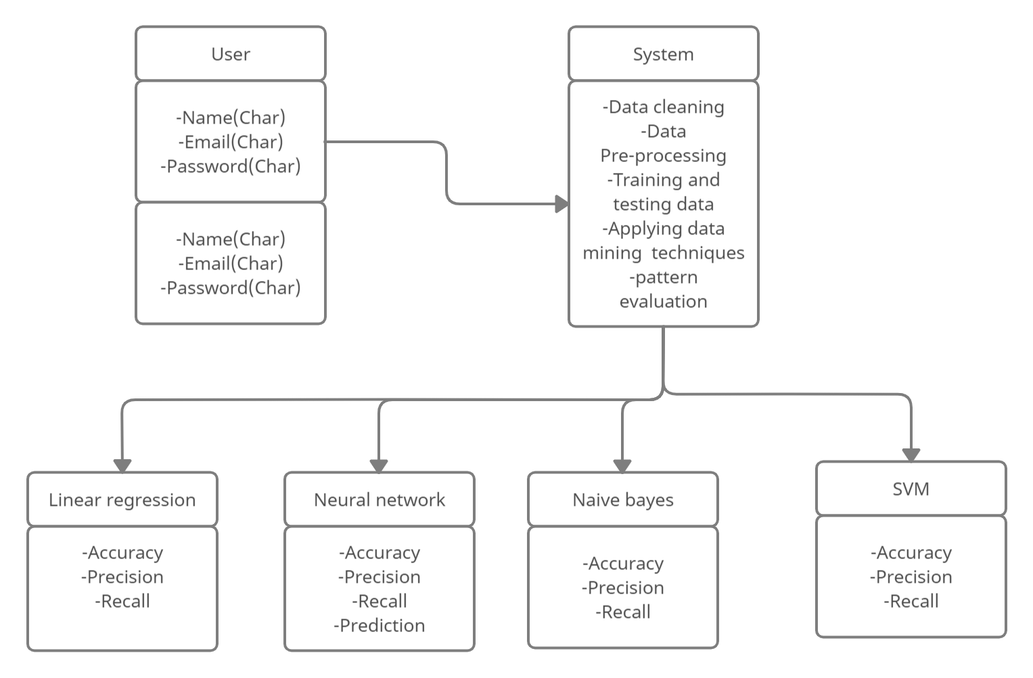

**Activity Diagram :**

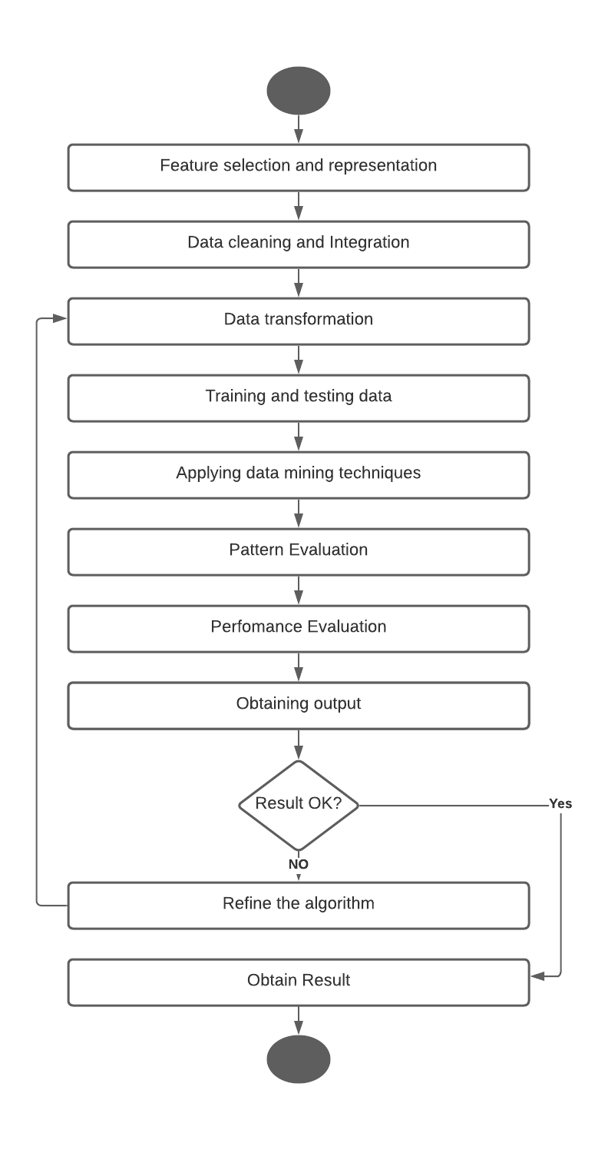

**Use Case Diagram :-**

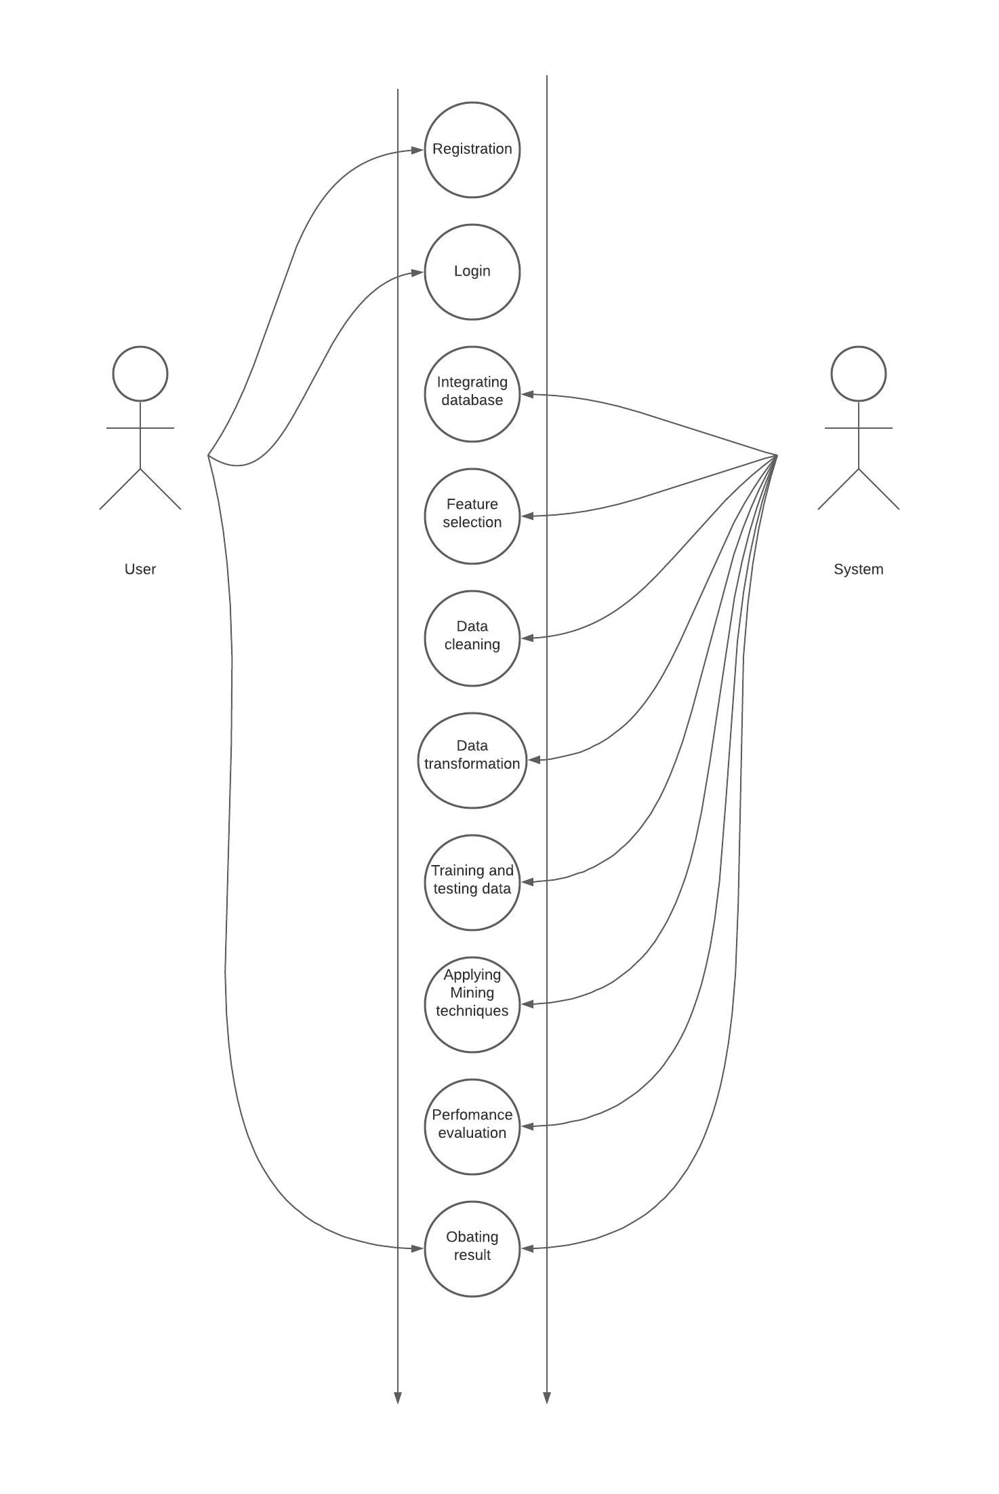

**Chapter 8**

**Advantages**

**Advantages:**

1. This method is used to detect high risk taxpayers in a minimum amount of time.
2. The power of this system is the combined use of regression techniques, support vector machines and prioritizing the high-income taxpayers.
3. The main feature is the amount of taxable income based on which the purchasing, sales, revenue and profit can be calculated.
4. This system Discovers fraud tax payers with potential tax responsibility and Improving compliance of tax deductors.

**Chapter 09**

**FUTURE MODIFICATIONS**

**&**

**CONCLUSION**

**Future Modification**

Tax avoidance is typically performed by the citizens to hack back liabilities and this unlawful activity is generally performed to distort the monetary realities to the government. This framework is utilized to incite high danger citizens United Nations organizations try not to settle individual assessment. This framework utilizes measure methods. The chief point of this investigation is to investigate measure methods for extortion charge forecast. In measure methods, issues like assessment misrepresentation recognition are by and large outlined as grouping issues, foreseeing a different class mark yield given an information perception. The chief cycle strategies utilized for charge misrepresentation discovery are action models, counterfeit neural organizations, the Bayesian organization, and decision trees.

**Conclusion**

Various ways are upheld to free the high threat electors however in applying the alluring residents' condition given the key amazing result stood out from the mean qualification, work issue, add fundamentally and modification-based manners by which. The power of this technique is the joint use of backslide ways, support vector machines and practicing inside the most significant level instalment residents.

**Chapter 10**

**BIBILIOGRAPHY**

**References**

[1] P. Ravisankar, V. Ravi, G.R. Rao, I. Bose, "Detection of financial statement fraud and feature selection using data mining technique," Decision Support Systems vol.50, no. 2, pp. 491-500, (2011).

[2] E.W.T. Ngai, Y. Hu, Y.H. Wong, Y. Chen, X. Sun, "The application of data mining techniques in financial fraud detection: A classification framework and an academic review of literature," Decision Support Systems vol.50, no. 3, pp. 559-569, (2011).

[3] P.C. González, J.D. Velásquez, "Characterization and detection of taxpayers with false invoices using data mining techniques," Expert Systems with Applications vol.40, no. 5, pp. 1427-1436, (2013).

[4] Central Michigan University, “Computational Data Mining Techniques in Automotive Insurance Fraud Detection”; Data Science Journal 2012.

[5]. B. Jyothi, Y. M. Latha, and V. S. K. Reddy, “Medical image retrieval using multiple features,” Research India Publications, vol. 3, pp. 387–396, 2010. Available: searchdl.org/public/book_series/AETS/7/546.pdf

[6] Z. Q. Song, H. Cui, and Y. A. Hu, “Research and development of support vector machine theory,” Journal of Naval Aeronautical Engineering Institute, vol. 23, no. 2, pp.143-148, 2008.

[ 7] Nazia Fathima S.M (2013) Classification of blood type by microscopic color images, International Journal of Machine Learning and Computing. Vol. 3, No. 4 Available: www.ijmlc.org/papers/342-L472.pdf

[ 8] Priyadharshini, Ramya, Kalaiyarasi, Kalpana Devi., SuthathiraVanitha.

A NOVEL APPROACH IN IDENTIFICATION OF BLOOD GROUP USING LASER TECHNOLOGY.

International Journal of Research in Engineering and Technology Volume: 03 Special Issue: 11 Available: www.ijret.org

[ 9] Mäenpää, Topi The local binary pattern approach to texture analysis-Extension and application

Available:http://urn.fi/urn:isbn:9514270762

**Chapter 11**

**SCREENSHOTS**

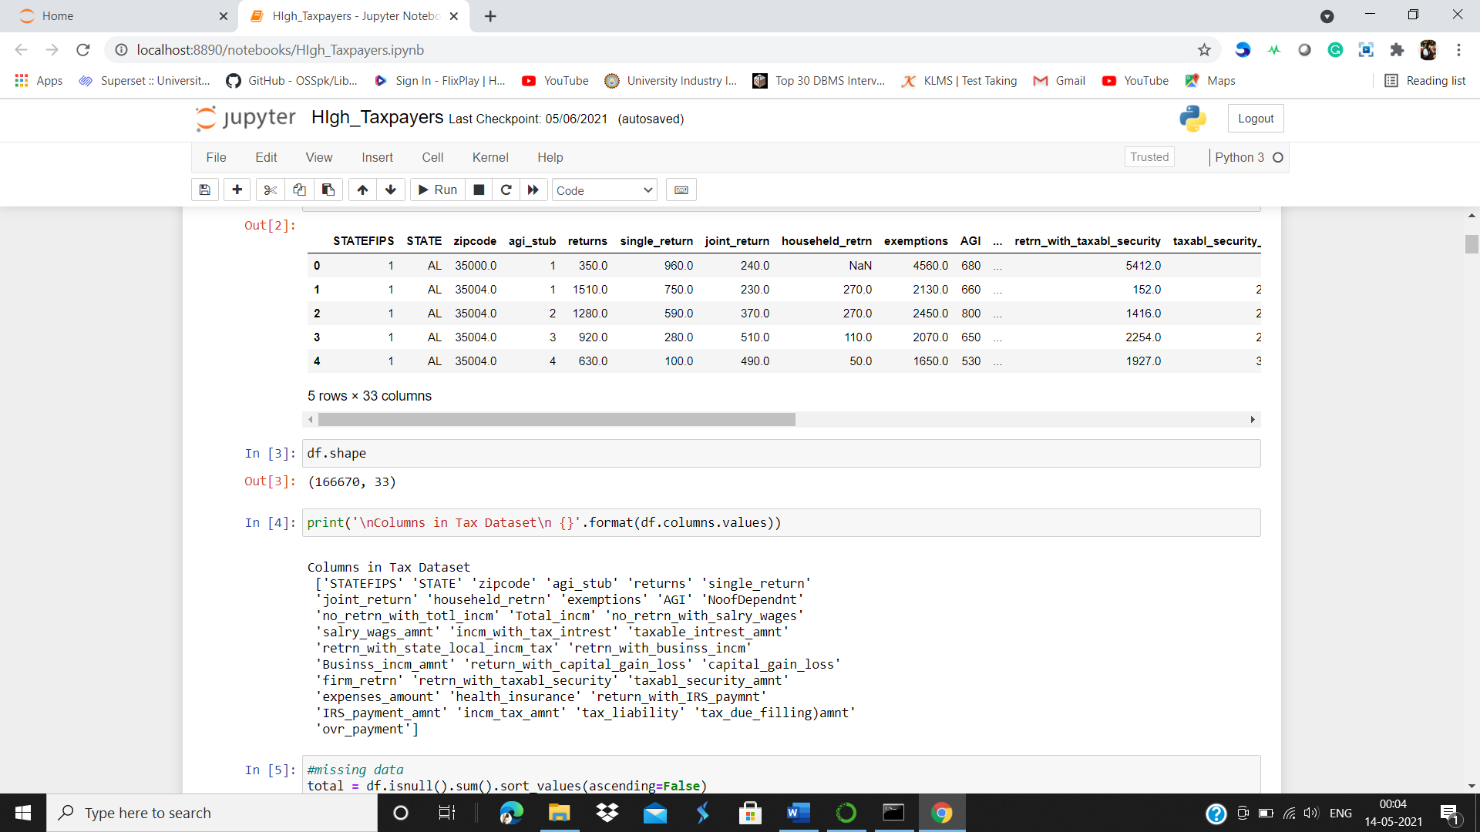

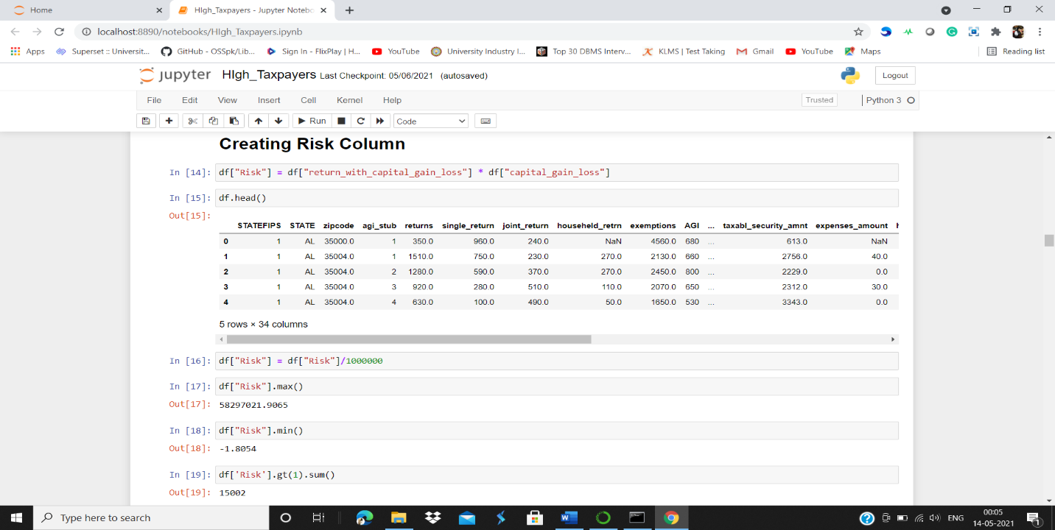

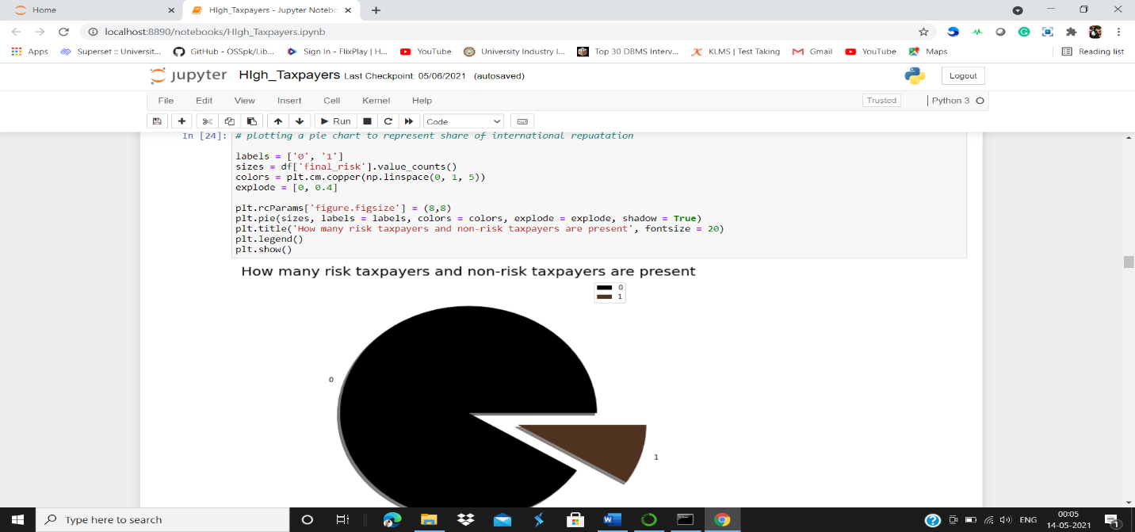

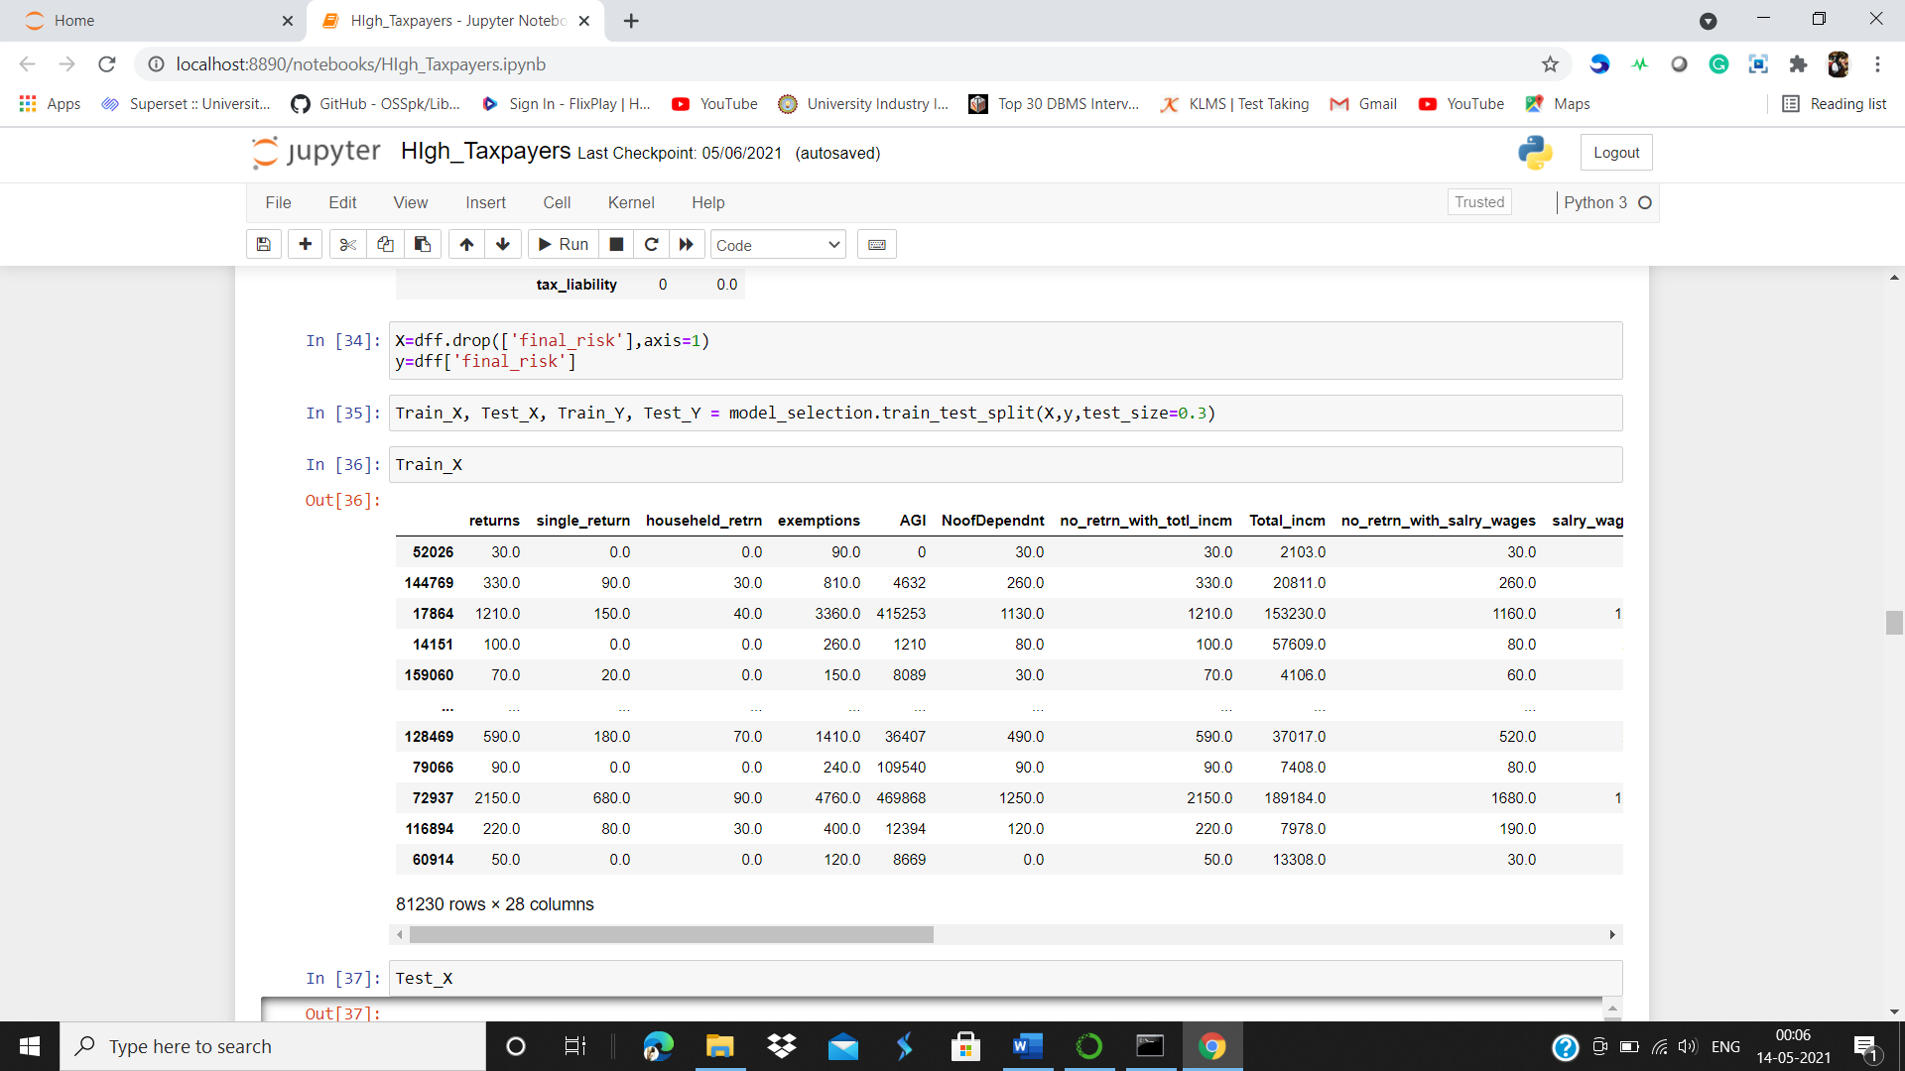

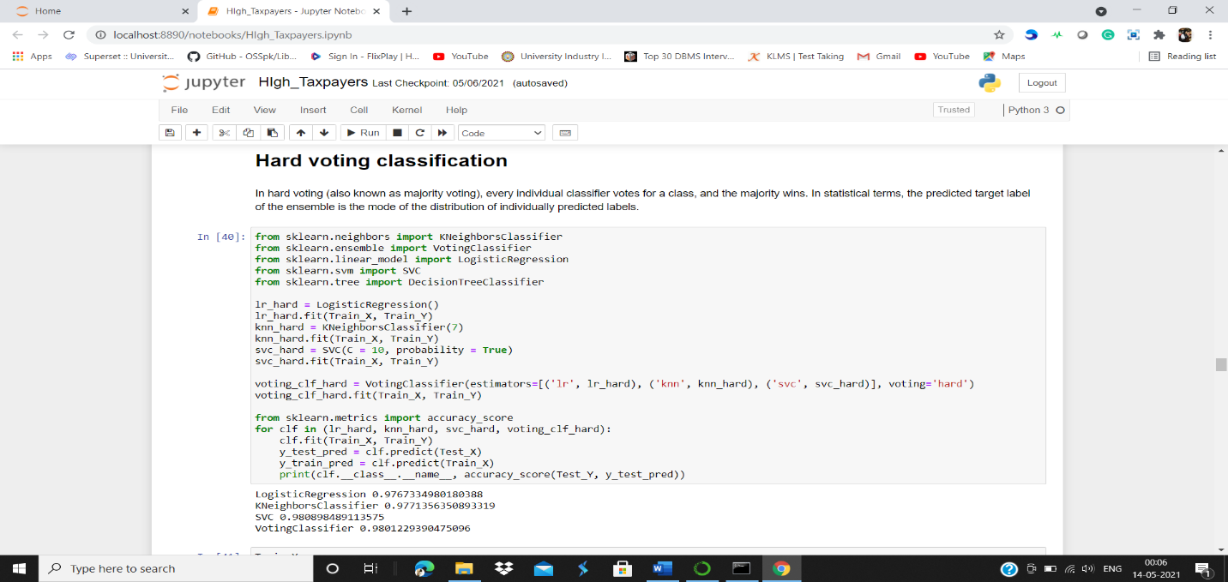

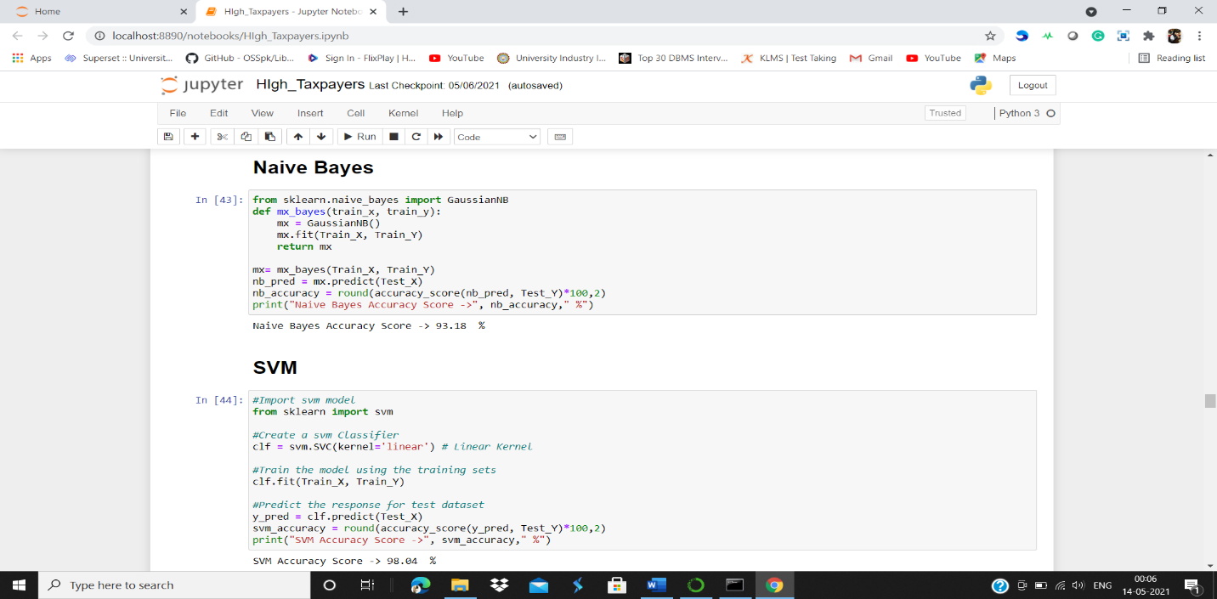

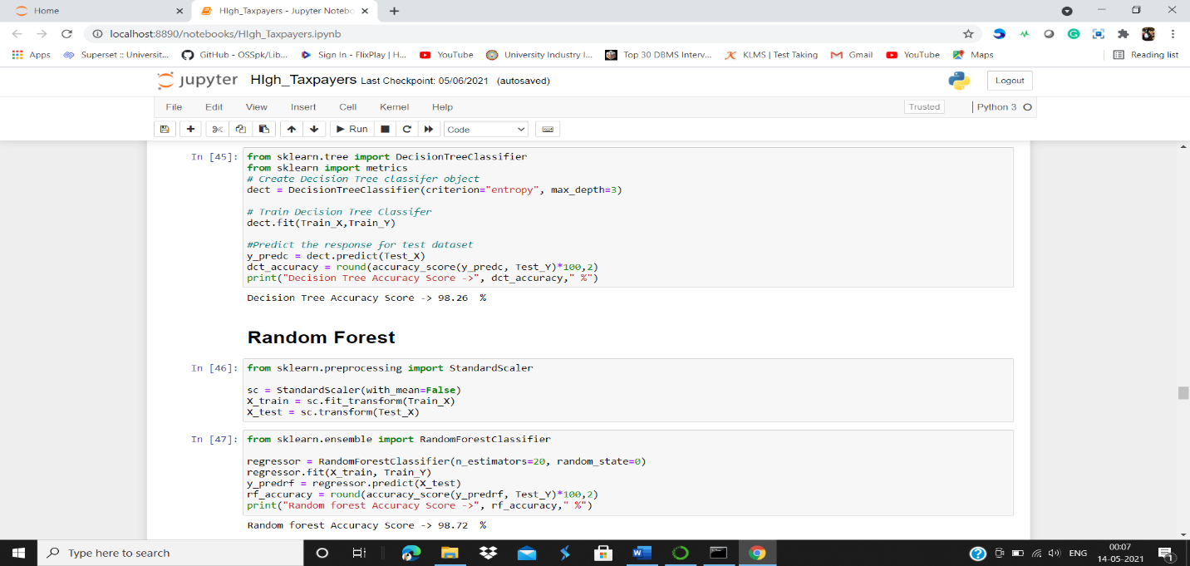

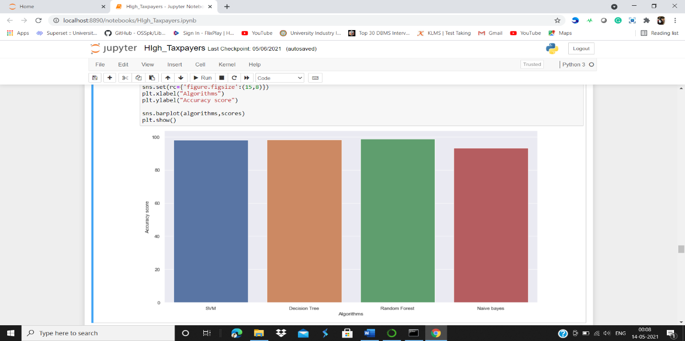





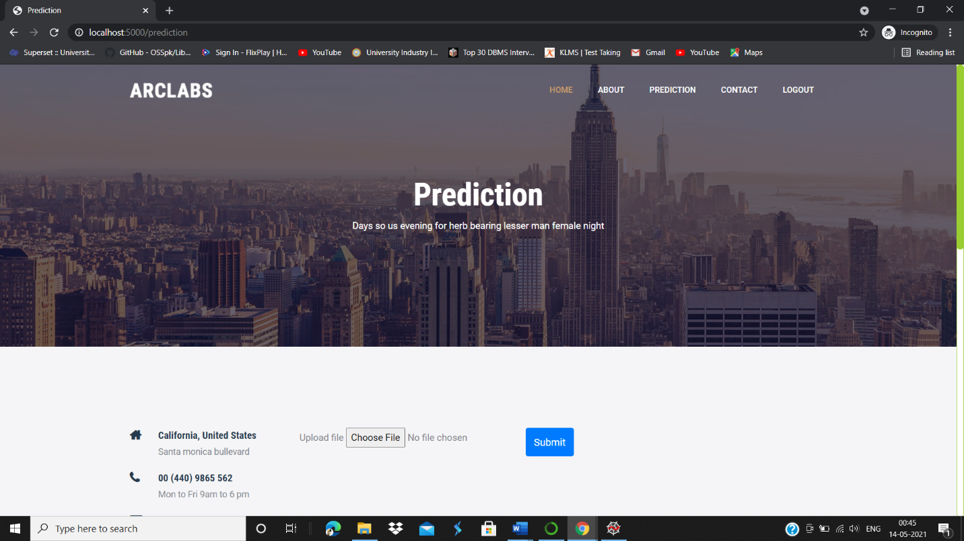

**Chapter 12**

**SOURCE CODE**

